Title: Network Traffic Analysis using Wireshark
Objective:
To capture and analyze network traffic to identify patterns and understand data flow.
Tools Used:
- Wireshark
Procedure:
- Installed Wireshark and Npcap
- Selected Wi-Fi interface
- Captured live network traffic
- Generated traffic by browsing websites
- Applied filters such as HTTP and DNS
- Analyzed packets
Observations:
- DNS queries were observed for domains like google.com and chatgpt.com
- TCP and TLS packets were captured
- Communication between local system and external servers was identified
- No suspicious activity detected
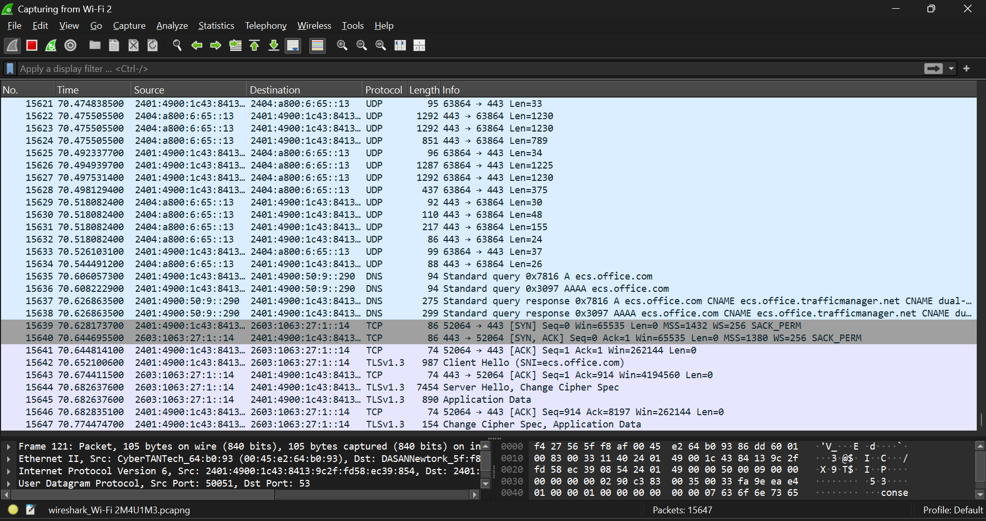
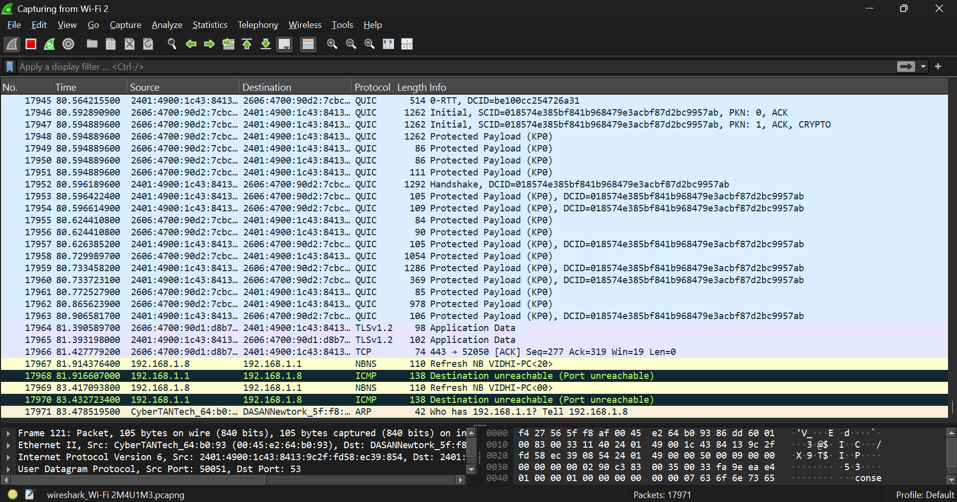
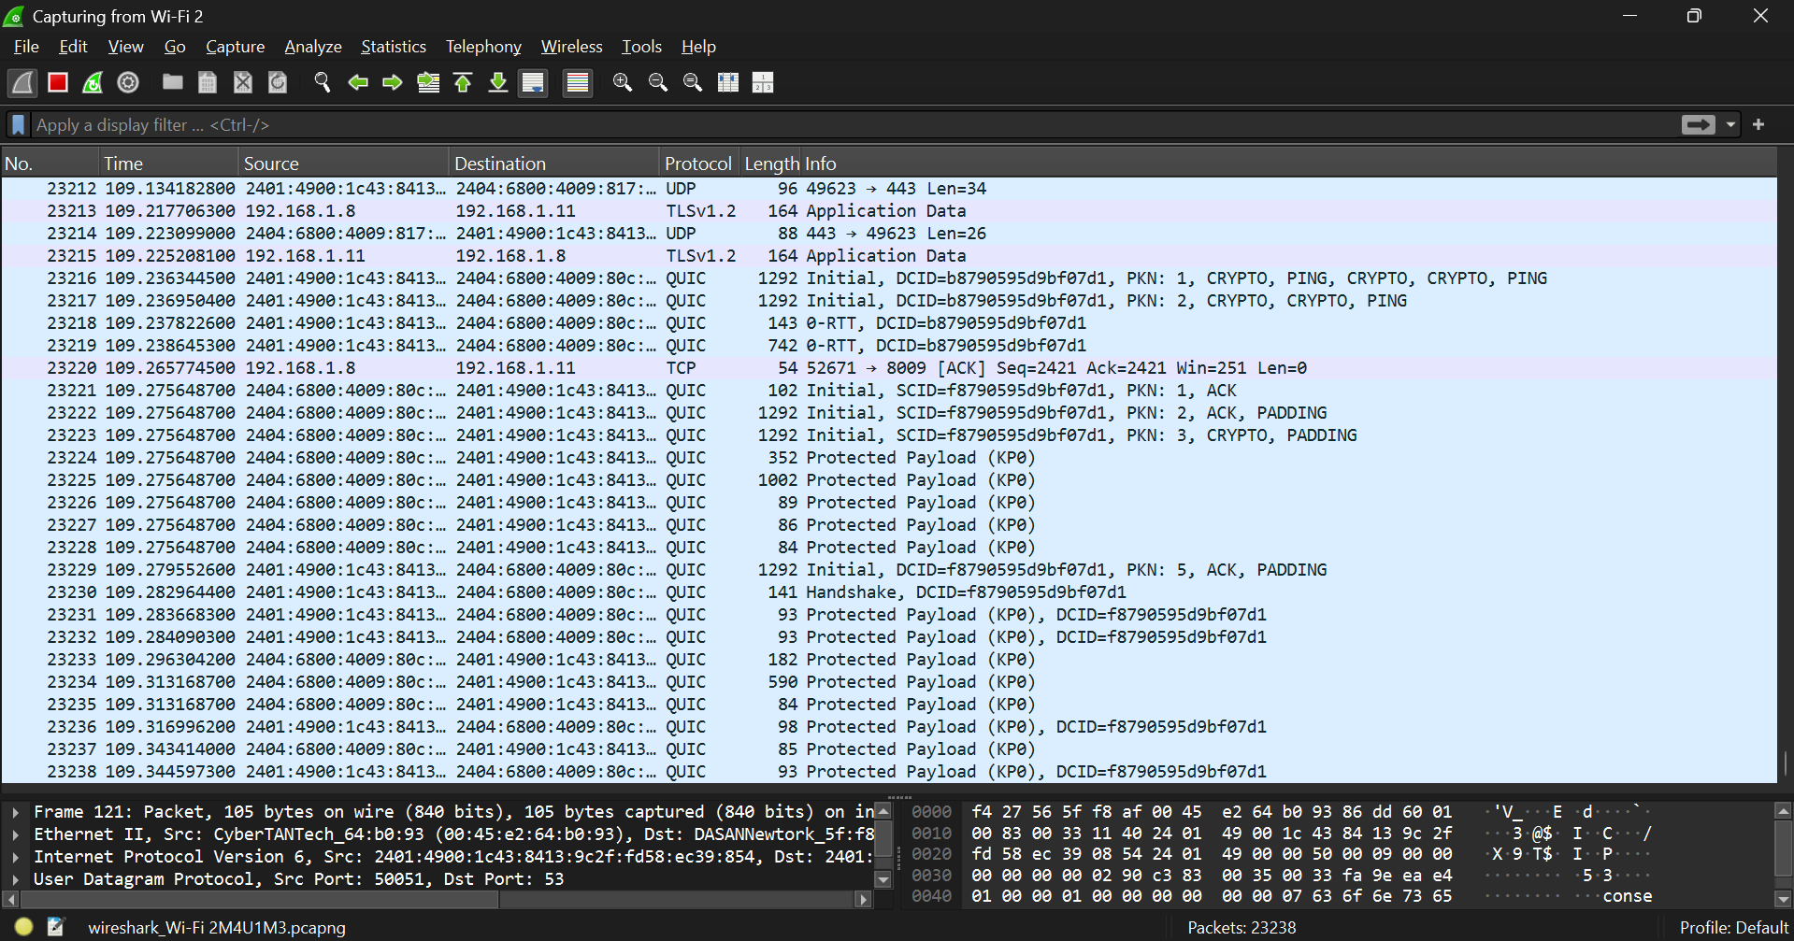
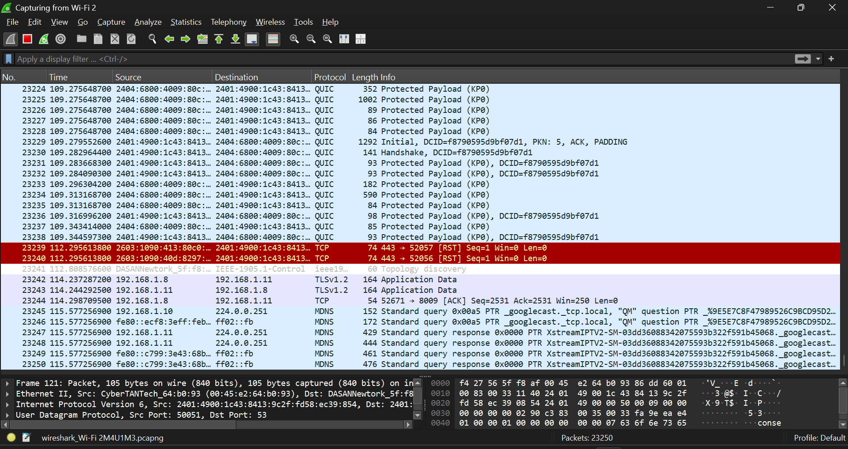
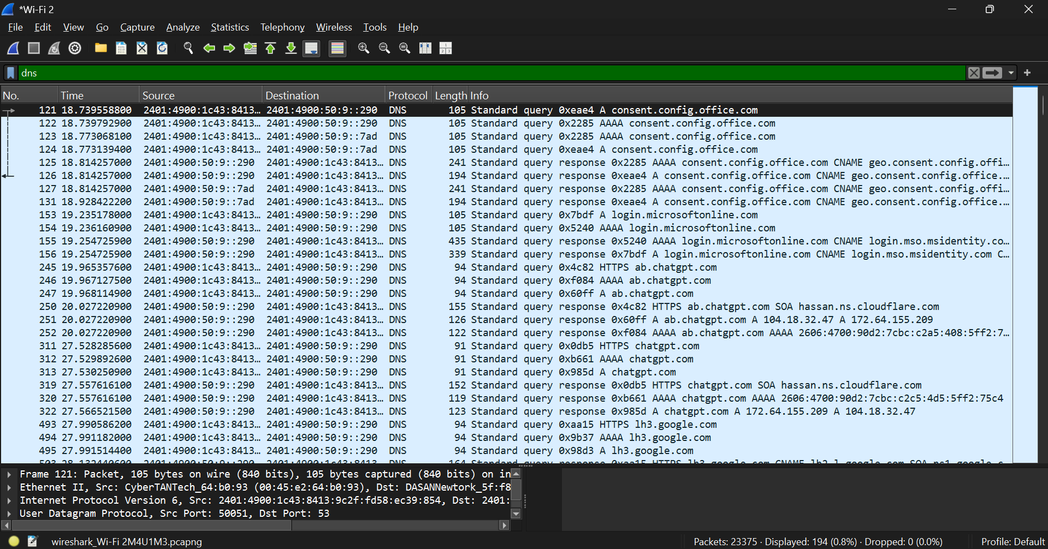
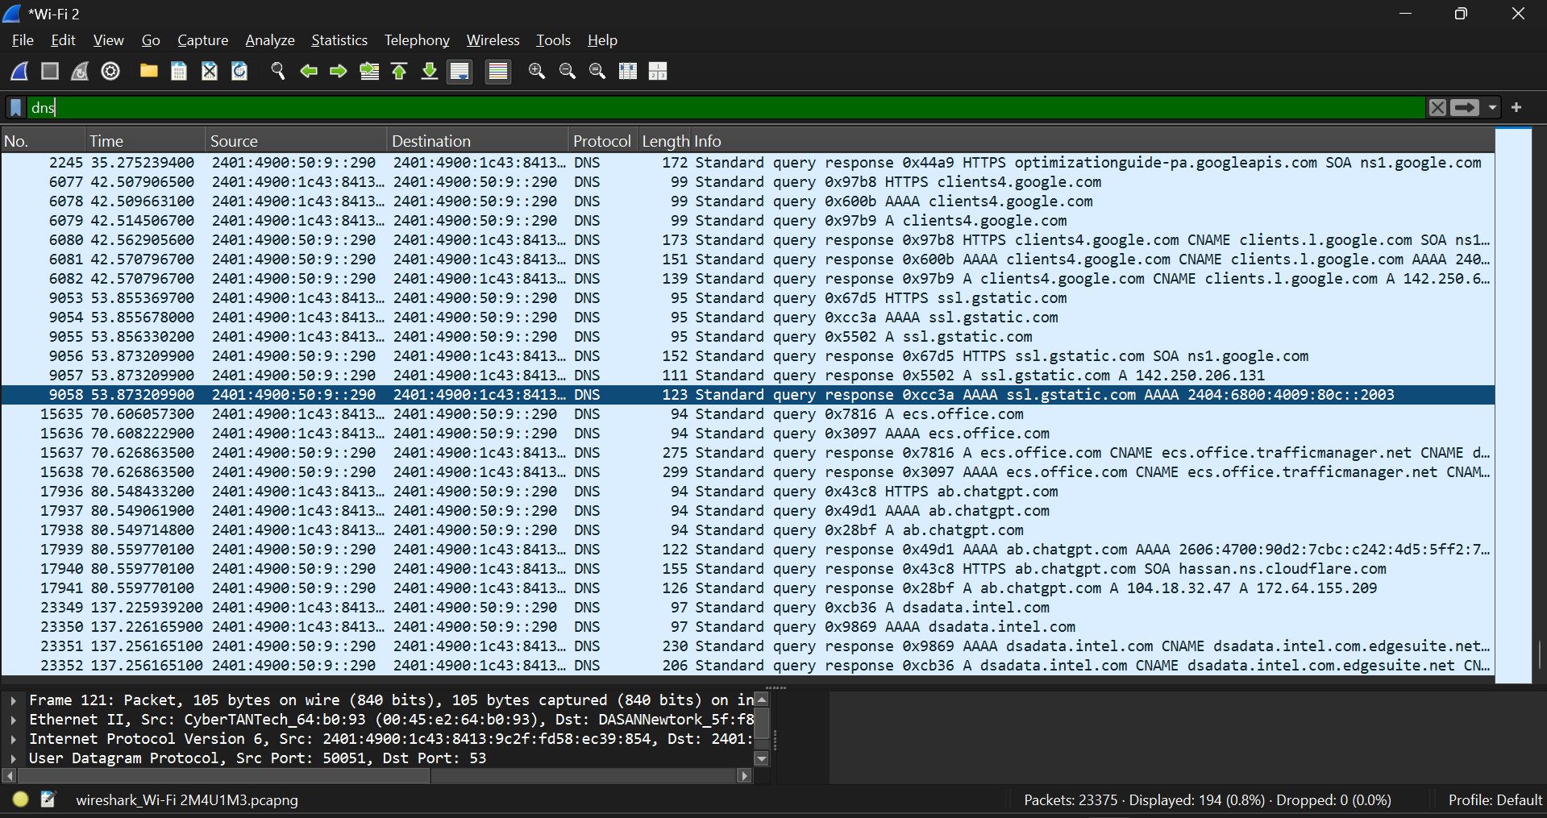
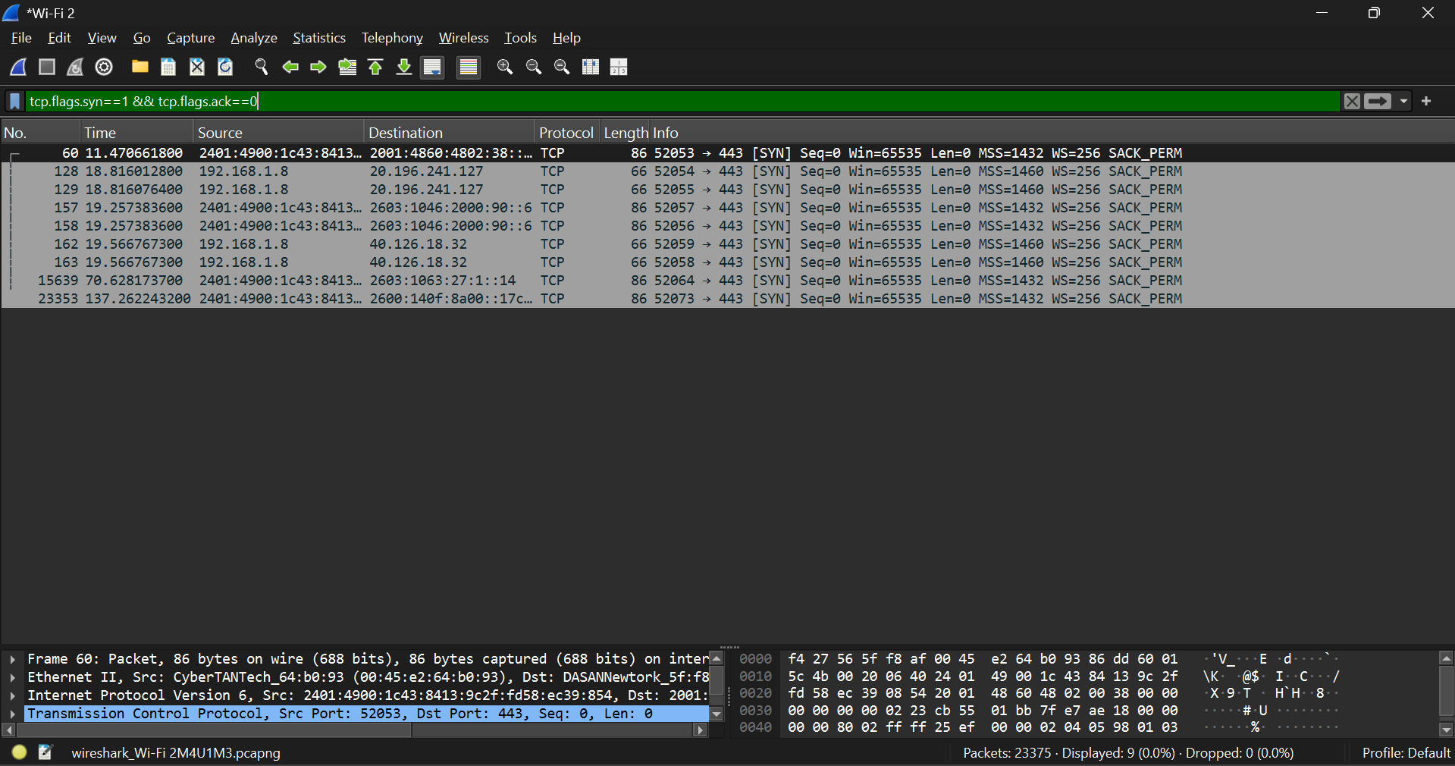
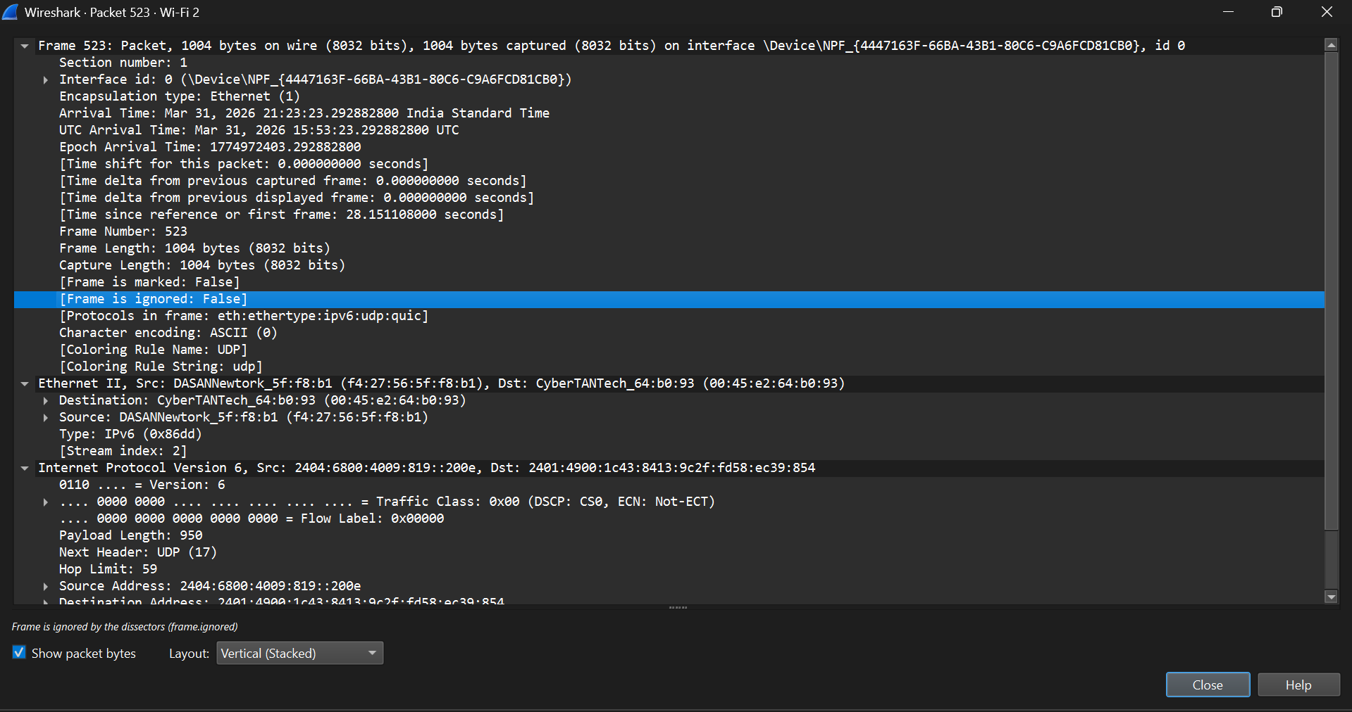
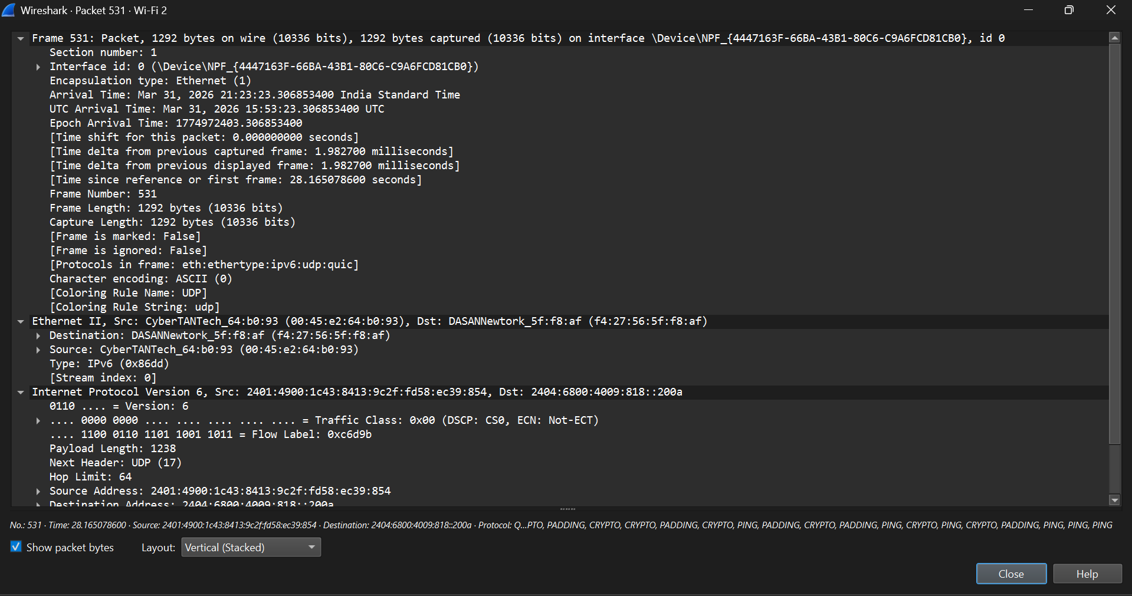
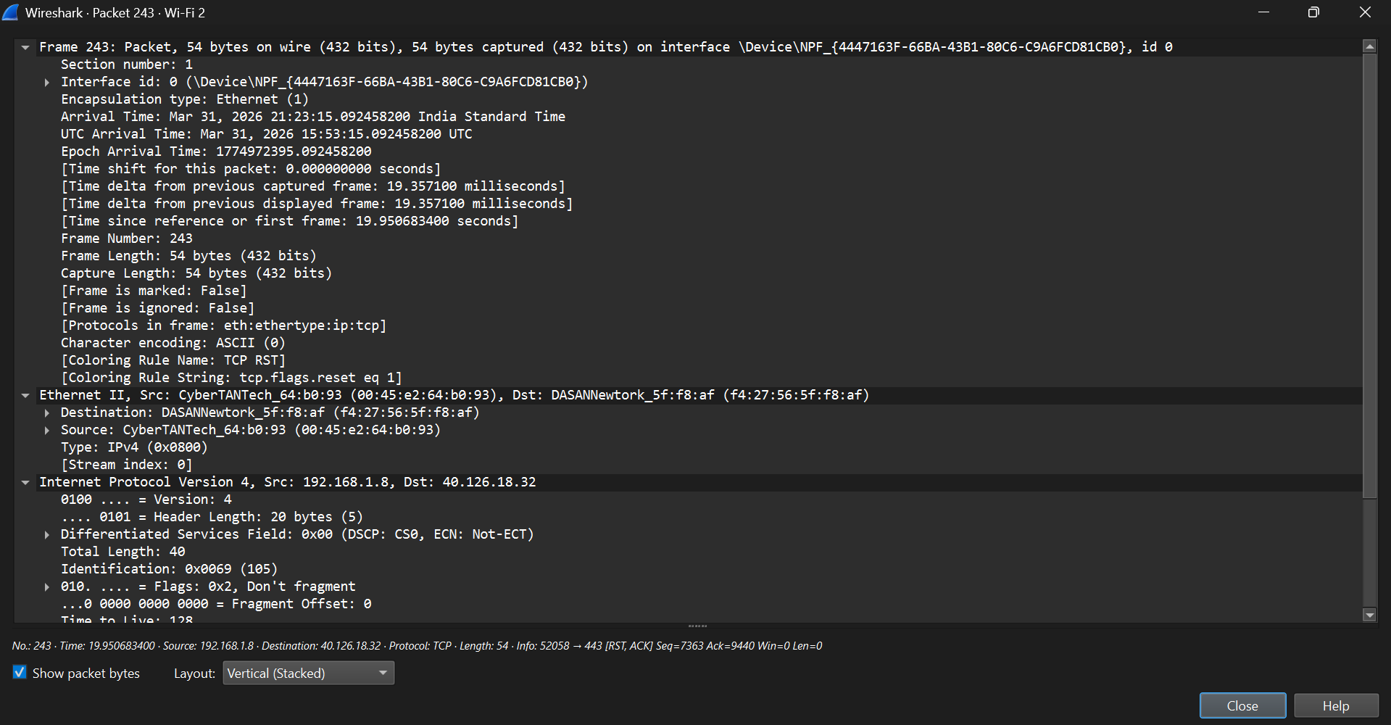
Conclusion:
Successfully captured and analyzed network traffic using Wireshark. Learned how to filter and interpret packets.

